Tpsrct gcash recover 恢复信息

垃圾搜搜all cant search this... only this pic

Change eml cant rev eml ...outlook gmal all test...i think is gcs bug

Change ph numb???

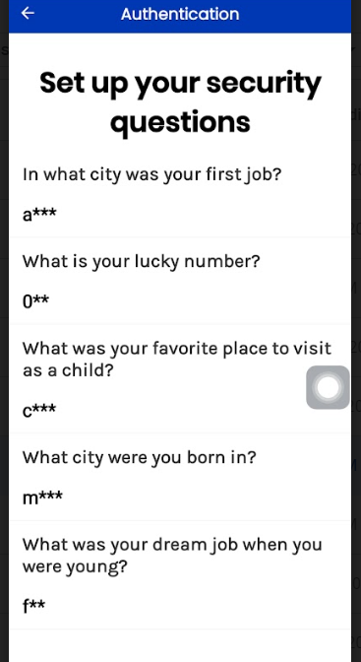

LINLINCY NUMB

MIZI BORN

FKX drm job fck

Fav place::city